**TripMate: Smart Travel and Carpool Management**

**Team: Tech Titans**

Sampreeth parsi (HU21CSEN0101411)

Moksha Sai (HU21CSEN0101291)

Karthik Pagidi (HU21CSEN0100708)

Yashaswi Rekha (HU21CSEN0101262)

Κ. ΜΑΝΙΚΑΝΤA (HU21EECE0100311)

**Overview**

TripMate is an innovative web application designed to streamline travel and carpool management. It offers a range of features aimed at simplifying the travel planning process for users and providing efficient management tools for administrators. The key features include online package enquiries, categorized travel packages, an admin panel for user and content management, carpooling options, and a trip cost estimator.

**Features**

**1. Online Package Enquiry**

Users can easily inquire about various travel packages available on the platform. The system provides a user-friendly interface to submit enquiries and receive responses.

**2. Subcategories for Packages**

Travel packages are organized into subcategories for better navigation and user experience. This categorization helps users find suitable packages based on their preferences.

**3. Admin Panel**

The admin panel is a powerful tool for managing the platform. Administrators can add, update, or delete users, categories, subcategories, and packages. They can also view and respond to user enquiries.

**4. Carpooling**

The carpooling feature allows users to find and join carpool groups, promoting cost-effective and environmentally friendly travel options.

**5. Trip Cost Estimator**

This tool provides users with an estimate of the cost for their planned trips, helping them budget effectively.

**Technology Overview**

Front End: HTML, CSS, JavaScript

**- HTML (HyperText Markup Language):**

HTML is used for creating and saving web documents. It forms the backbone of the TripMate website, structuring the content and layout of the web pages. HTML files are created using editors like Notepad or Notepad++.

**- CSS (Cascading Style Sheets):**

CSS is used to create attractive layouts for the website. It enhances the visual appeal of the web pages, ensuring a pleasant user experience. CSS is also utilized to ensure consistent styling across the entire platform.

**- Bootstrap:**

Bootstrap is a framework used for creating responsive and mobile-friendly designs. It ensures that TripMate is accessible and functional across various devices, providing a seamless experience for users on smartphones, tablets, and desktops.

**- JavaScript:**

JavaScript is a versatile programming language commonly used with web browsers. In TripMate, JavaScript is employed to add interactivity and dynamic elements to the web pages, enhancing user engagement.

**Back End: PHP, MySQ**

**- PHP (Hypertext Preprocessor):**

PHP is an open-source server-side scripting language that enables developers to create dynamically generated web pages. It is used in TripMate to handle server-side logic, process user requests, interact with the database, and generate the appropriate responses. PHP's flexibility and efficiency make it an ideal choice for developing robust web applications.

**- MySQL:**

MySQL is a widely used relational database management system. It is employed in TripMate to store and manage data, including user information, travel packages, enquiries, and carpool details. MySQL provides efficient querying, updating, and management capabilities, ensuring that the data is organized and accessible.

**Features in Detail**

**Online Package Enquiry**

The online package enquiry feature allows users to browse through available travel packages and submit enquiries for more information. The system collects user details and enquiry specifics, which are then stored in the MySQL database. The admin panel provides administrators with an interface to view and respond to these enquiries, ensuring timely and accurate information delivery.

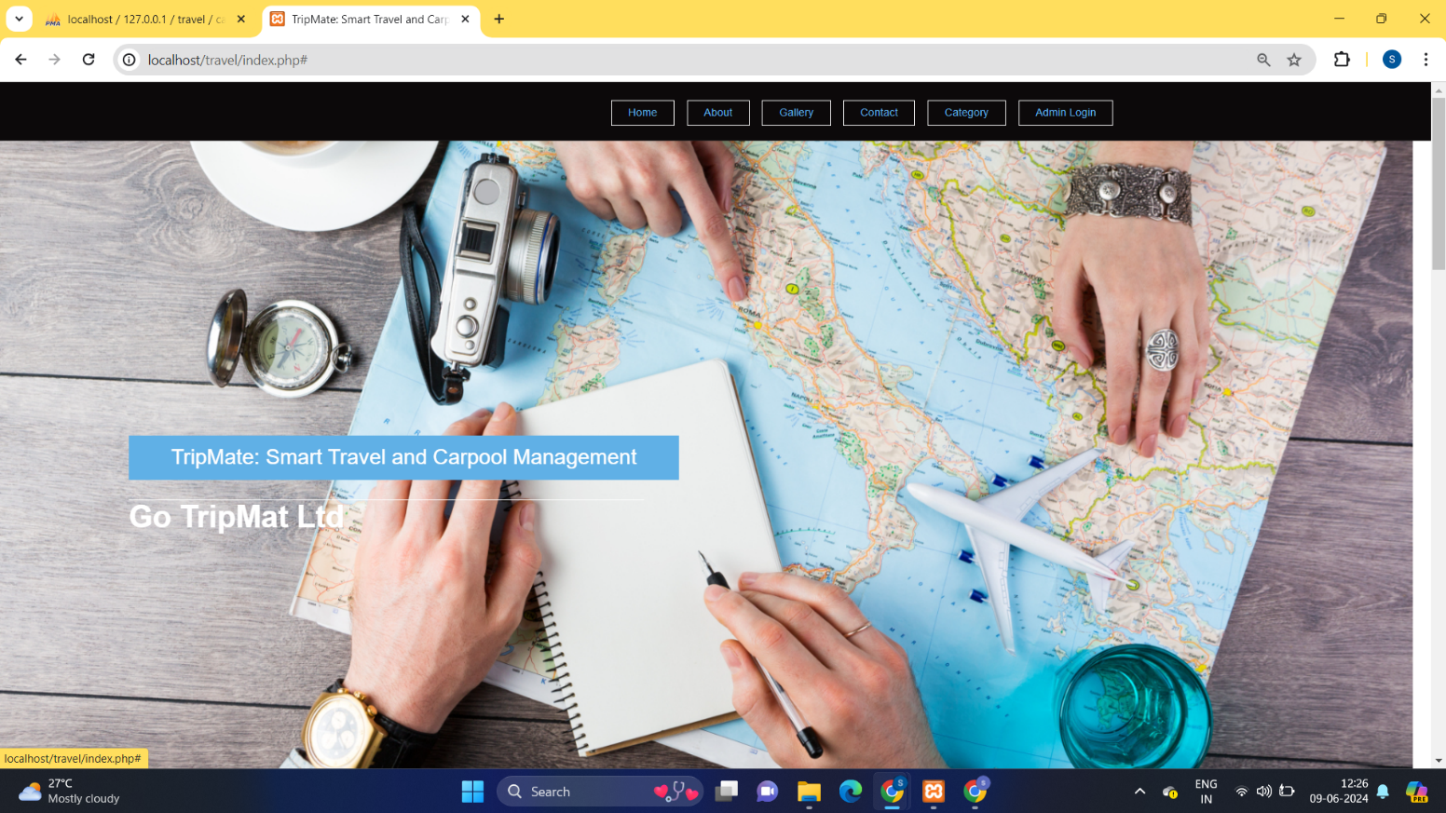

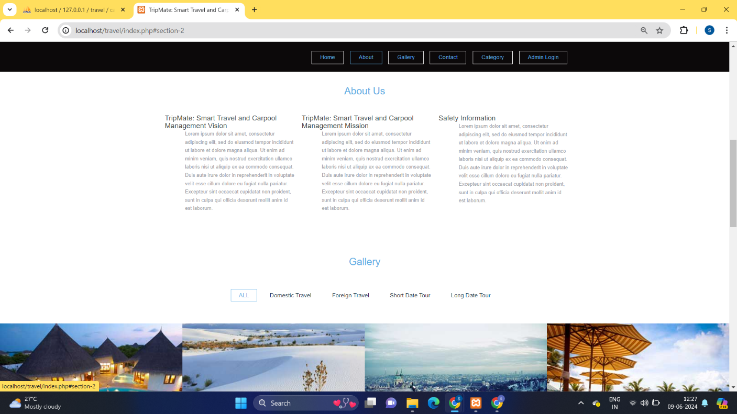

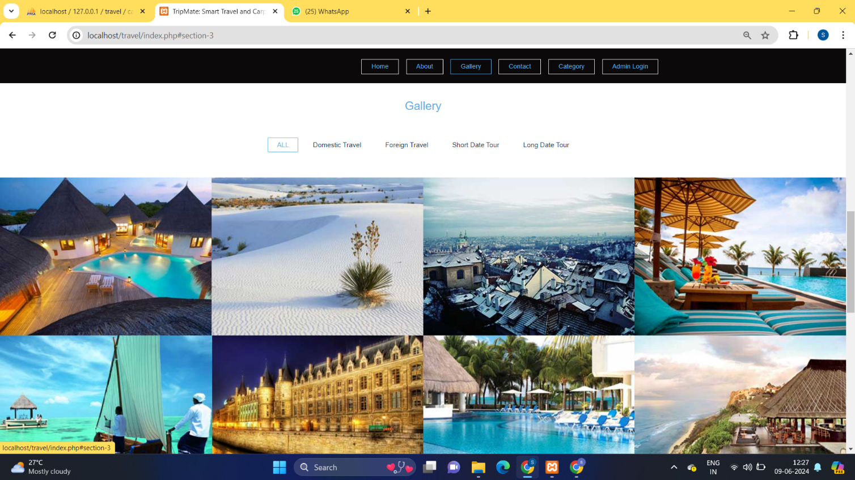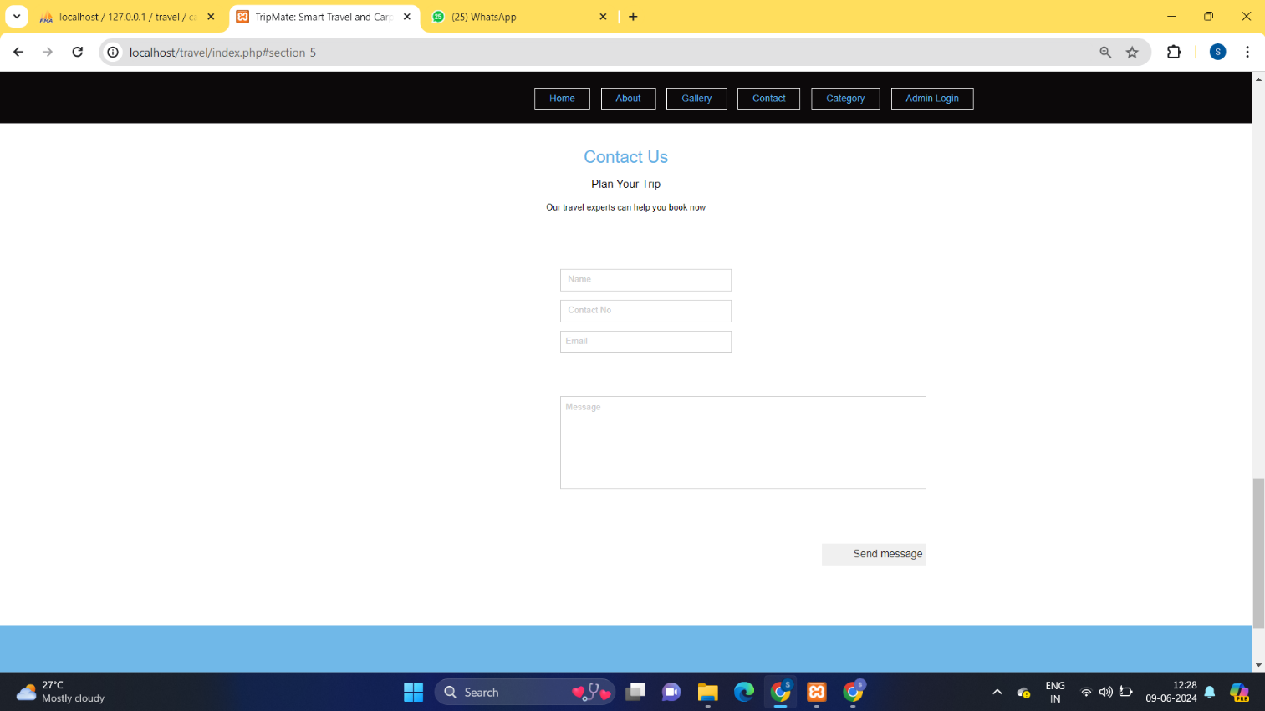

**Subcategories for Packages**

Packages are categorized into various subcategories, such as destination type, travel duration, and package type (e.g., adventure, leisure, business). This hierarchical organization helps users quickly locate packages that match their interests. The categorization is managed through the admin panel, allowing administrators to easily add, update, or delete categories and subcategories.

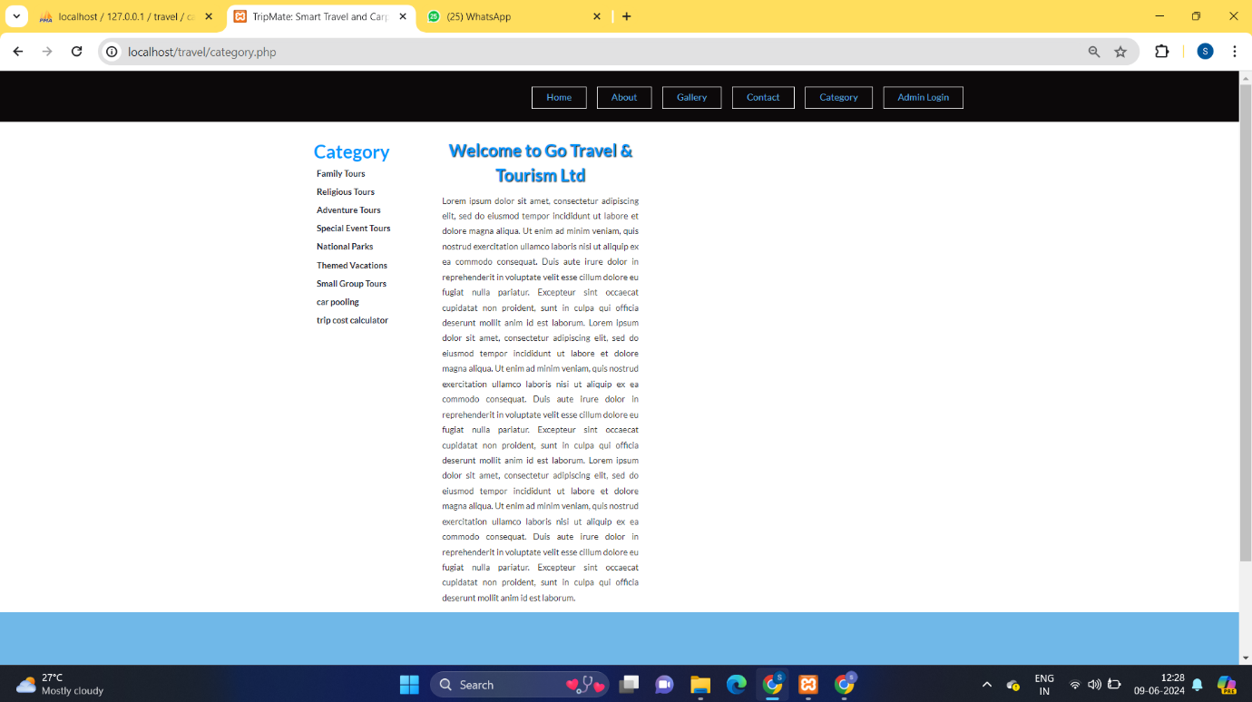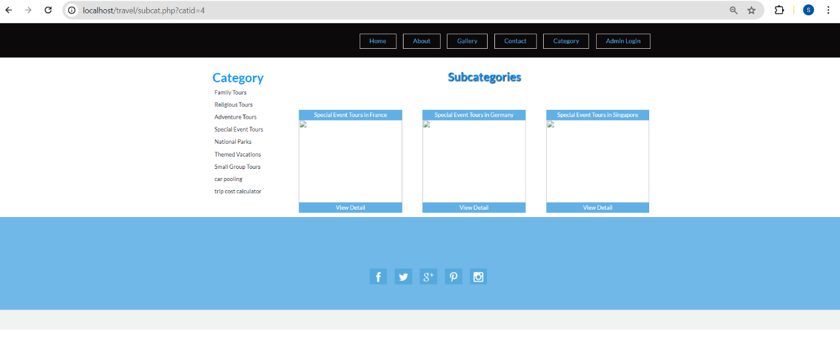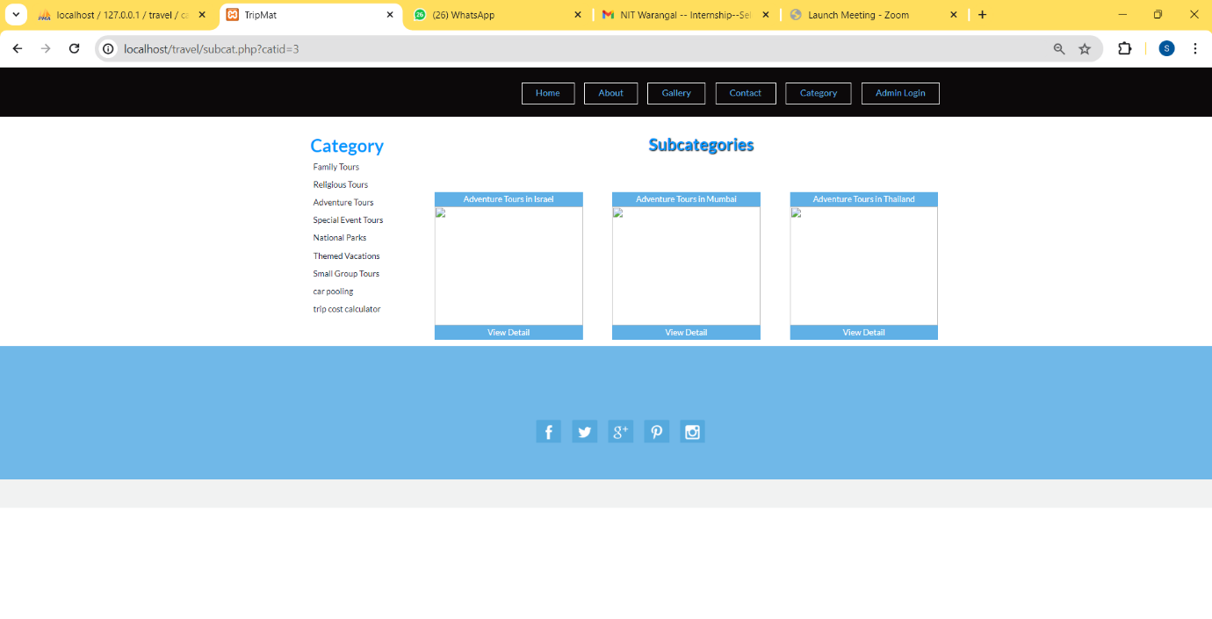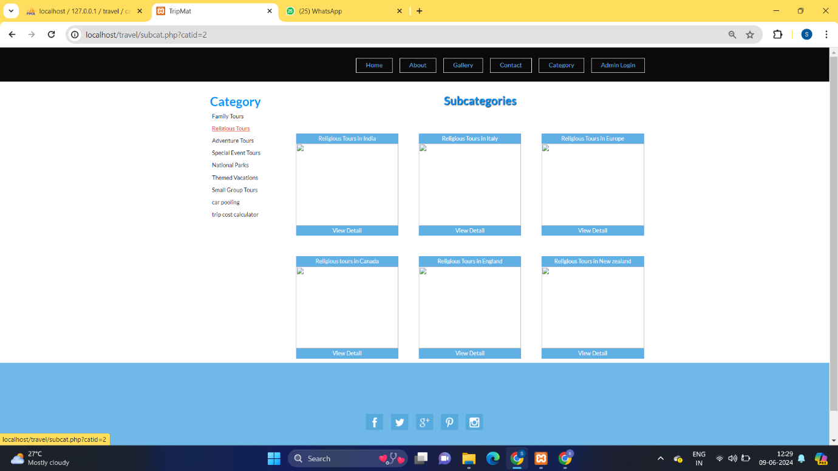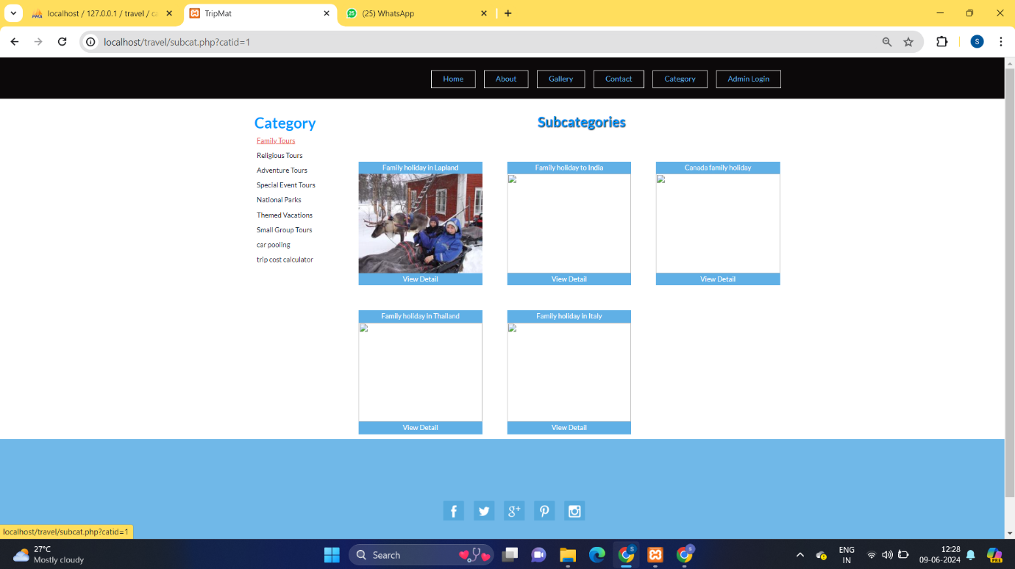

**Admin Panel**

The admin panel is a comprehensive management tool for administrators. It includes the following functionalities:

-User Management: Add, update, or delete user accounts.

- Category Management: Create, modify, or remove categories and subcategories.

- Package Management: Add new packages, update existing ones, or delete outdated packages.

- Enquiry Management: View and respond to user enquiries, ensuring effective communication between users and administrators.

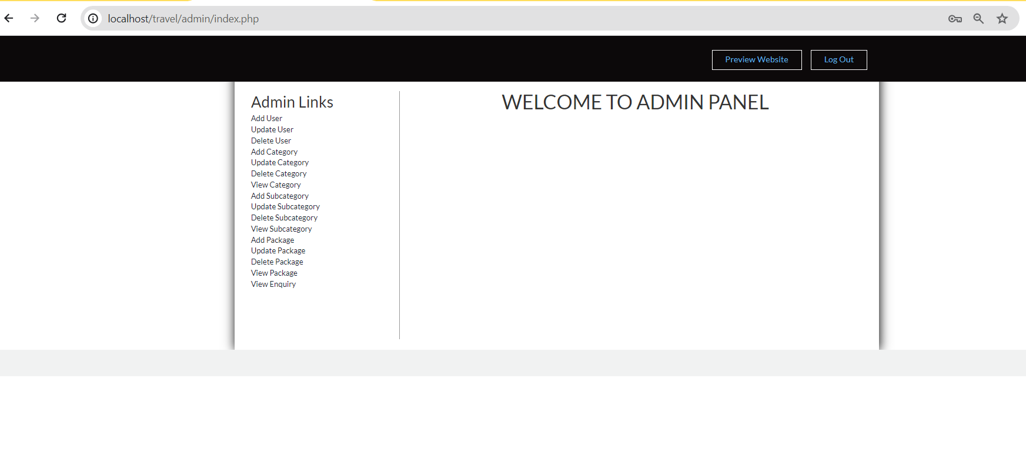

**Carpooling**

The carpooling feature promotes shared travel by allowing users to join or create carpool groups. Users can search for carpool options based on their travel routes and schedules. This feature not only reduces travel costs but also minimizes environmental impact by reducing the number of vehicles on the road. 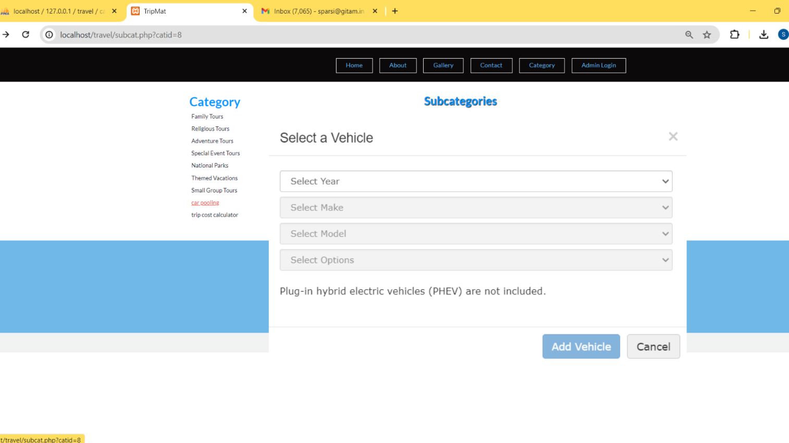

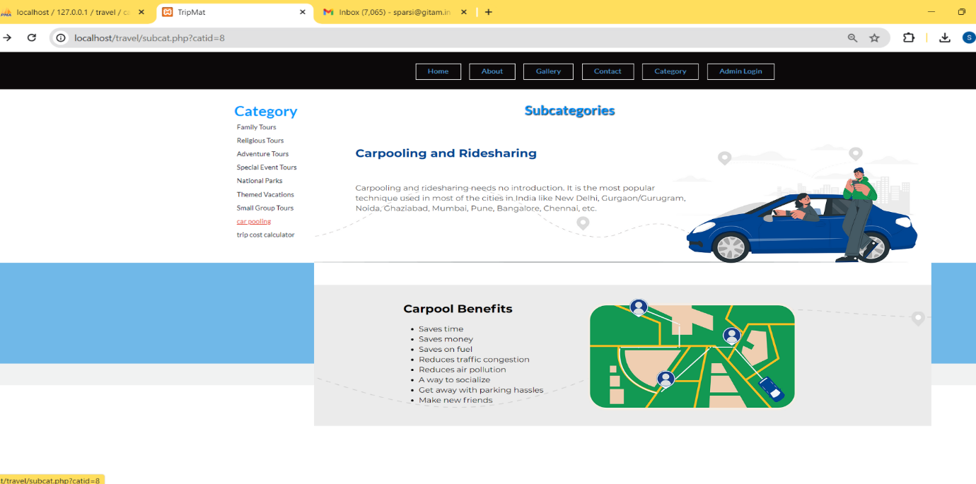

**Trip Cost Estimator**

The trip cost estimator provides users with an approximate cost for their planned trips. Users input their travel details, such as destination, duration, and number of travelers, and the system calculates the estimated cost based on predefined rates and parameters. This feature helps users plan their trips more effectively by providing a clear understanding of potential expenses. 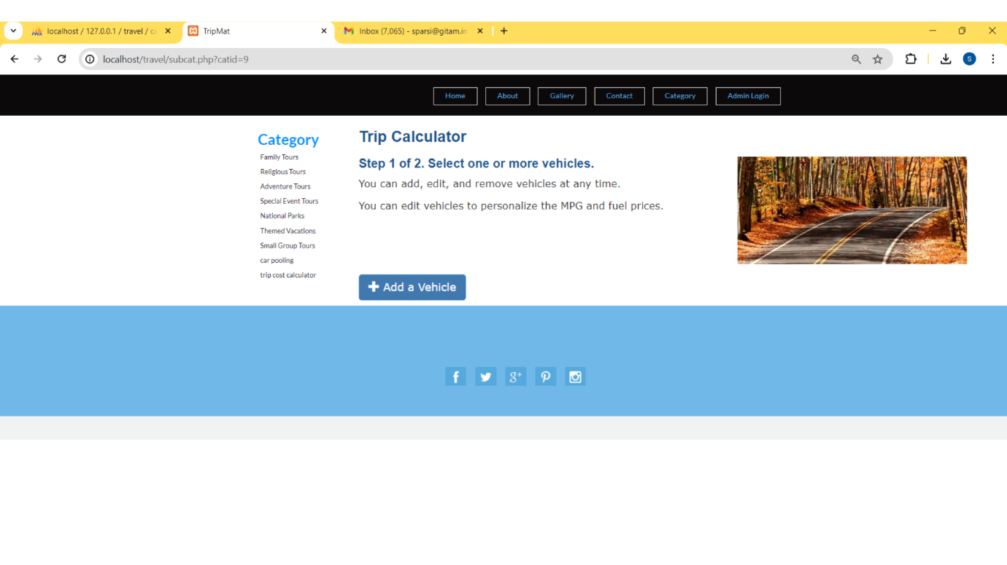

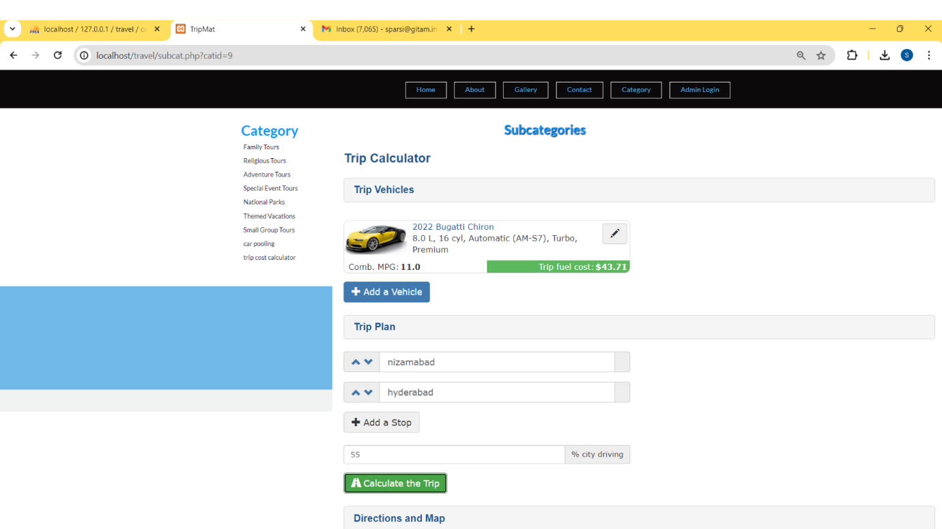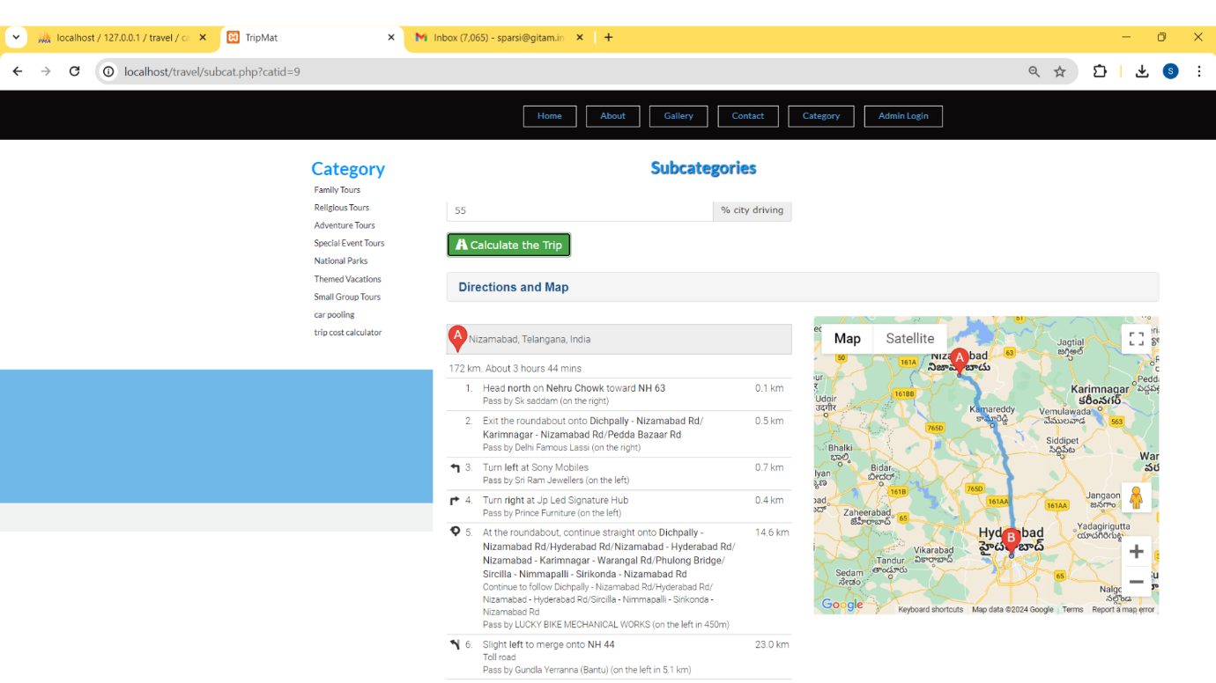

**Conclusion**

TripMate, developed by the Tech Titans team, is a comprehensive solution for modern travel and carpool management. By leveraging front-end technologies like HTML, CSS, JavaScript, and Bootstrap, and back-end technologies like PHP and MySQL, TripMate offers a robust and user-friendly platform. It addresses the needs of travelers and administrators alike, providing efficient tools for package enquiries, carpooling, and trip cost estimation. With its innovative features and intuitive design, TripMate is set to transform the way people plan and manage their travel experiences.